STRING BUILDER

1. example

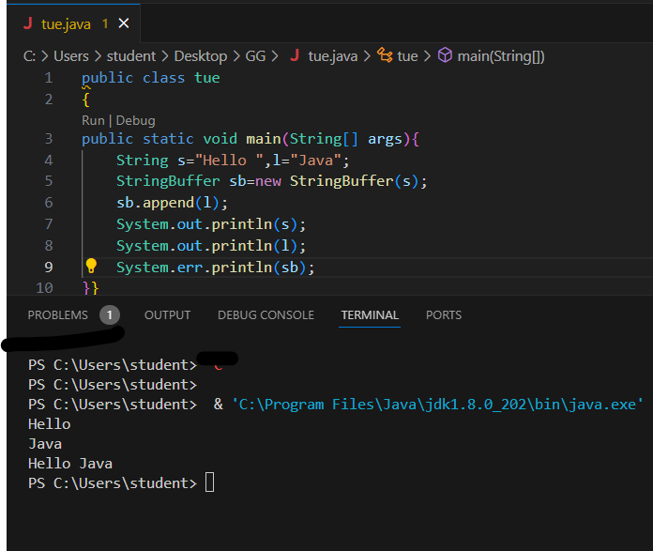

public class tue

public static void main(String[] args){

    String s="Hello ",l="Java";

    StringBuffer sb=new StringBuffer(s);

    sb.append(l);

    System.out.println(s);

    System.out.println(l);

    System.err.println(sb);

}}

2. INSERT AND REPLACE METHODS

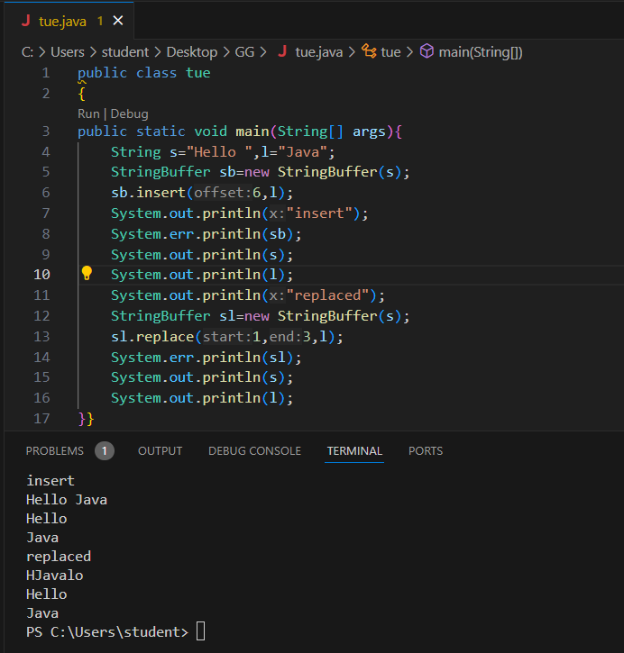

public class tue

{

public static void main(String[] args){

    String s="Hello ",l="Java";

    StringBuffer sb=new StringBuffer(s);

    sb.insert(6,l);

    System.out.println("insert");

    System.err.println(sb);

    System.out.println(s);

    System.out.println(l);

    System.out.println("replaced");

    StringBuffer sl=new StringBuffer(s);

    sl.replace(1,3,l);

    System.err.println(sl);

    System.out.println(s);

    System.out.println(l);

}}

3. DELETE and reverse

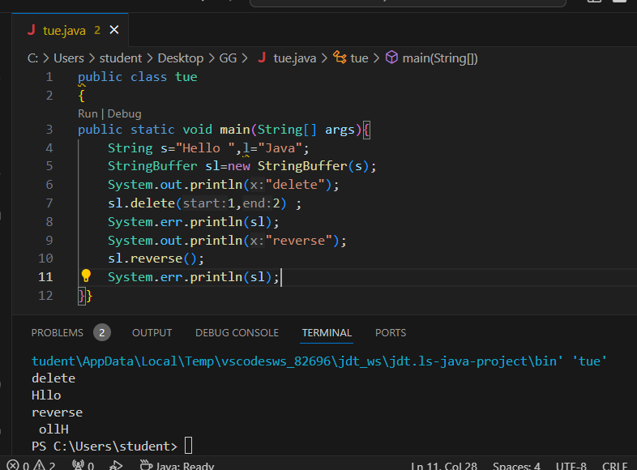

public class tue

{

public static void main(String[] args){

    String s="Hello ",l="Java";

    StringBuffer sl=new StringBuffer(s);

    System.out.println("delete");

    sl.delete(1,2) ;

    System.err.println(sl);

    System.out.println("reverse");

    sl.reverse();

    System.err.println(sl);

}}

4. capacity error

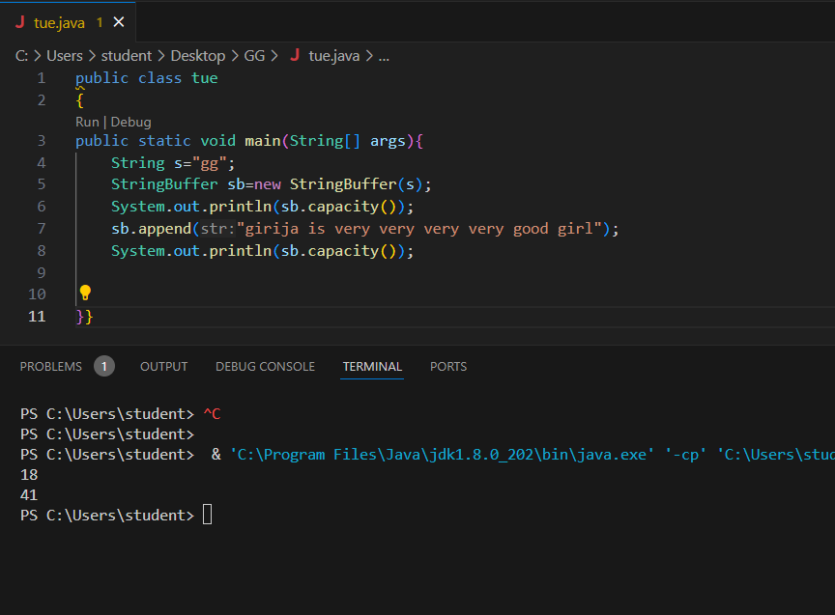

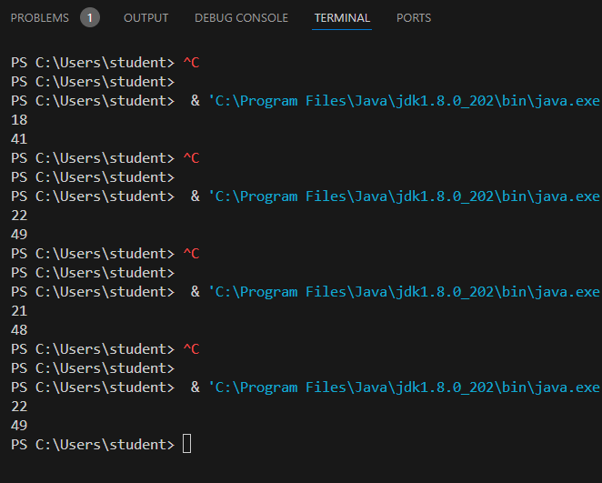

public class tue

{

public static void main(String[] args){

    String s="gg";

    StringBuffer sb=new StringBuffer(s);

    System.out.println(sb.capacity());

    sb.append("girija is very very very very good girl");

    System.out.println(sb.capacity());

}}

5.EnsureCapacity

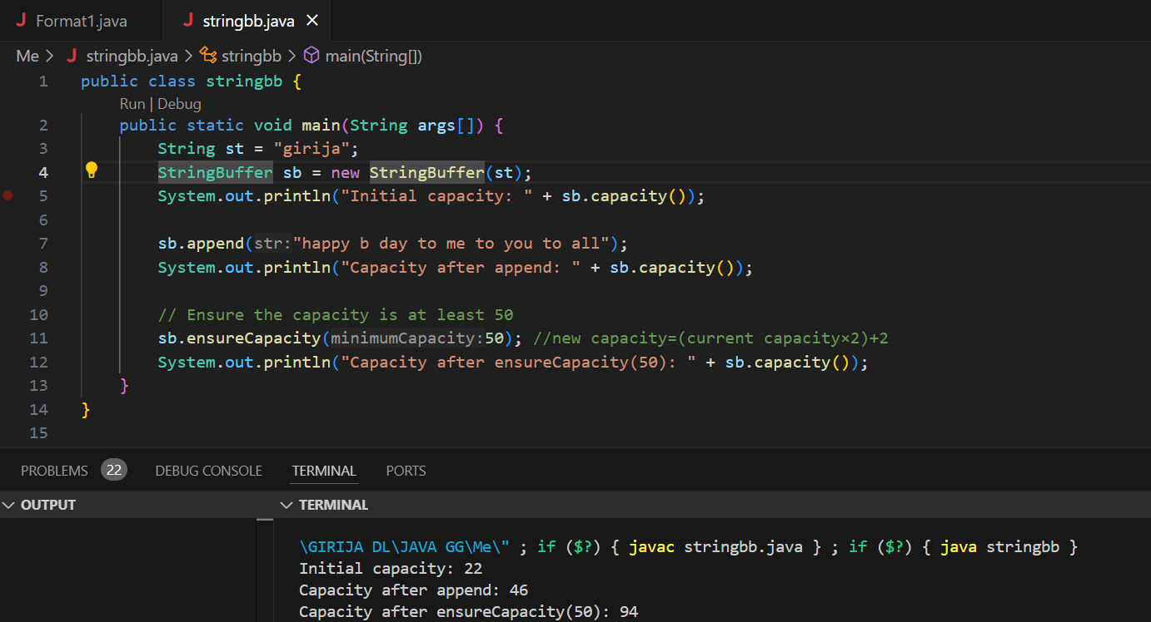

5. String builder

1.example

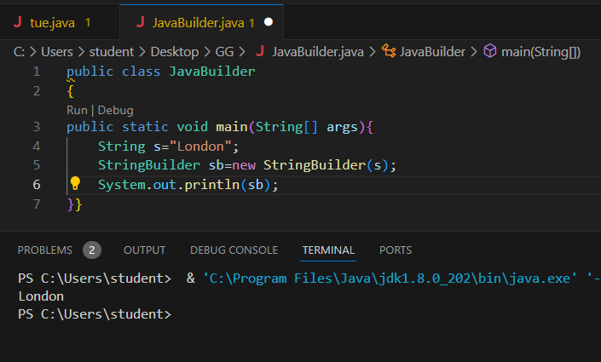

public class JavaBuilder

{

public static void main(String[] args){

    String s="London";

    StringBuilder sb=new StringBuilder(s);

    System.out.println(sb);

}}

2.append

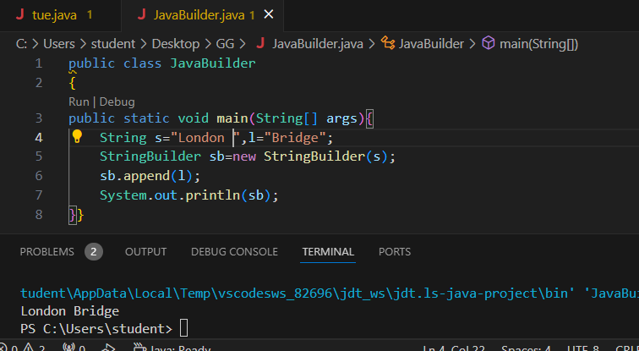

public class JavaBuilder

{

public static void main(String[] args){

    String s="London ",l="Bridge";

    StringBuilder sb=new StringBuilder(s);

    sb.append(l);

    System.out.println(sb);

}}

3.insert and replace

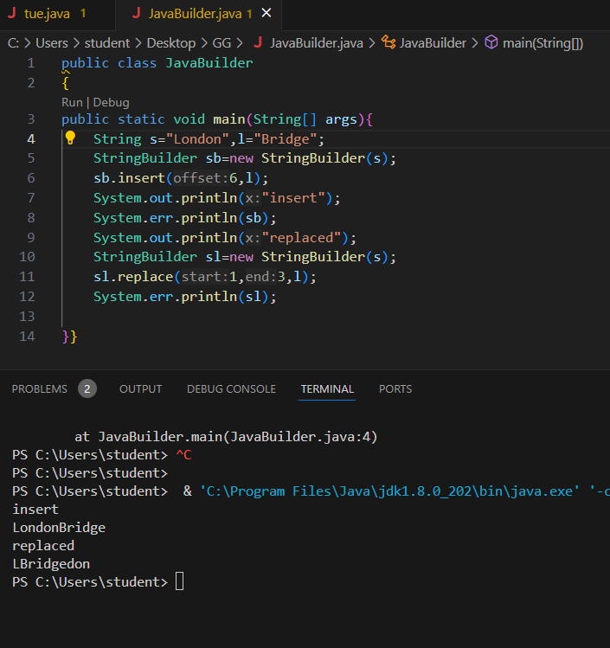

public class JavaBuilder

{

public static void main(String[] args){

    String s="London",l="Bridge";

    StringBuilder sb=new StringBuilder(s);

    sb.insert(6,l);

    System.out.println("insert");

    System.err.println(sb);

    System.out.println("replaced");

    StringBuilder sl=new StringBuilder(s);

    sl.replace(1,3,l);

    System.err.println(sl);

}}

4.reverse and delete

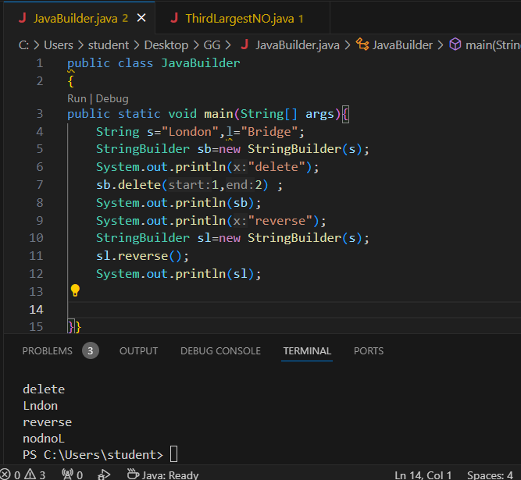

public class JavaBuilder

{

public static void main(String[] args){

    String s="London",l="Bridge";

    StringBuilder sb=new StringBuilder(s);

    System.out.println("delete");

    sb.delete(1,2) ;

    System.out.println(sb);

    System.out.println("reverse");

    StringBuilder sl=new StringBuilder(s);

    sl.reverse();

    System.out.println(sl);

}}

5. capacity and ensureCapacity

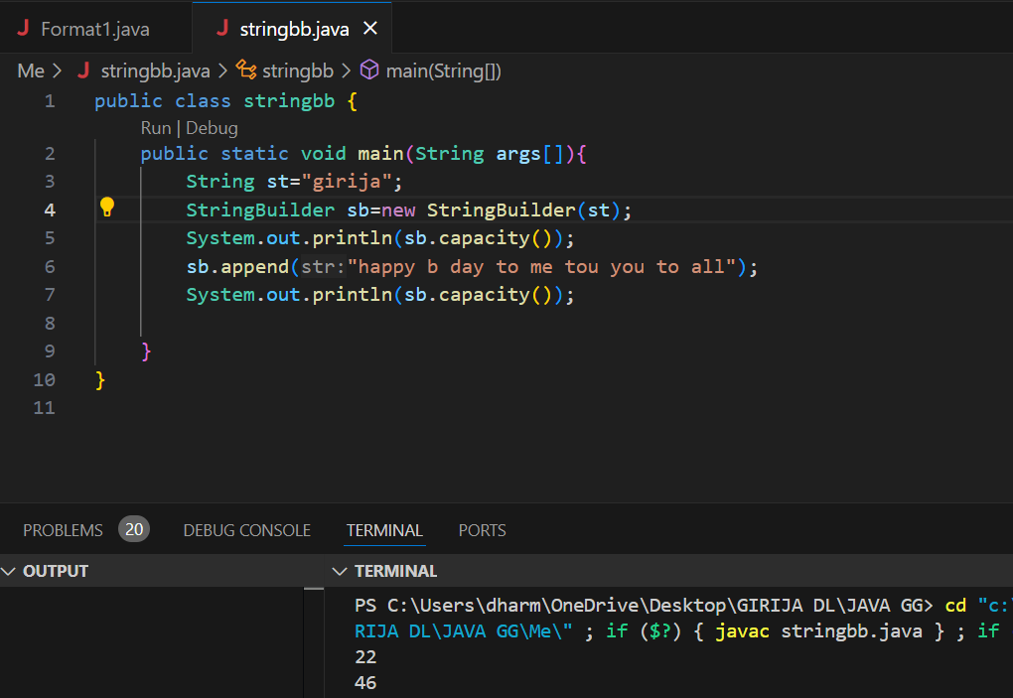

5.ensure capacity

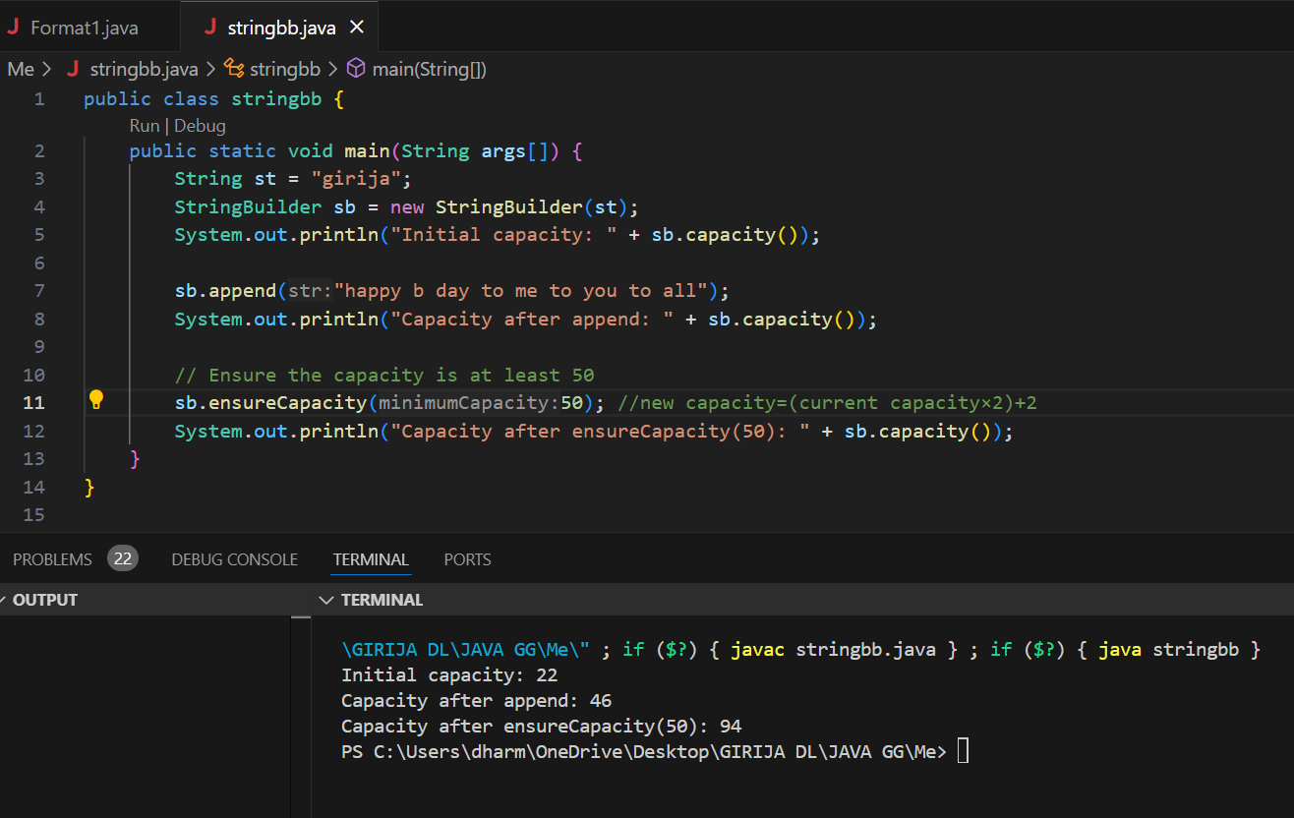

6. third highest number

import java.util.Scanner;

public class ThirdLargestNO{

    public static void main(String[] args){

        System.out.println("enter no.of elements");

        Scanner sc=new Scanner(System.in);

        int n=sc.nextInt();

        int arr[]=new int[n];

        for (int i=0;i<n;i++){

            System.out.println("enter element "+i+1);

            arr[i]=sc.nextInt();

        }

        //third largest number

        int n1=arr[0],n2=0,n3=0;

        for (int i=0;i<n;i++){

            for(int j=i+1;j<n;j++){

                if (arr[i]>arr[j]){

                    n3=n2;

                    n2=n1;

                    n1=arr[j];

                }

            }

        }

        System.out.println("third largest numbver is ="+n3);

    }

}

StringTokenizer

1.

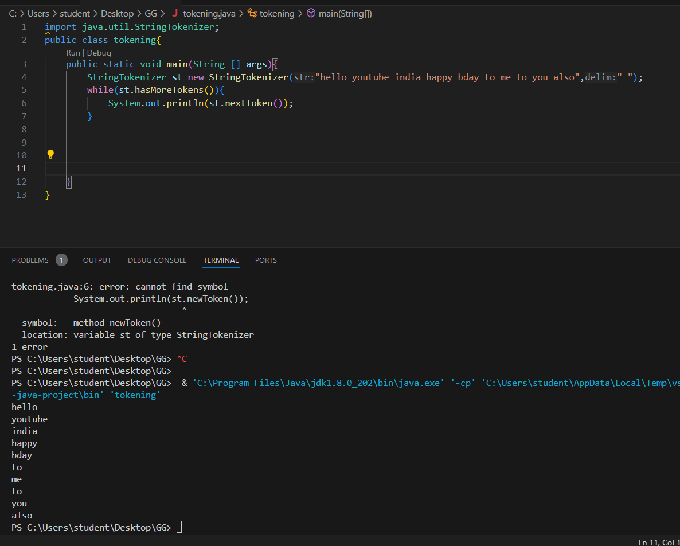

import java.util.StringTokenizer;

public class tokening{

    public static void main(String [] args){

        StringTokenizer st=new StringTokenizer("hello youtube india happy bday to me to you also"," ");

        while(st.hasMoreTokens()){

            System.out.println(st.nextToken());

        }

    }

}

1..

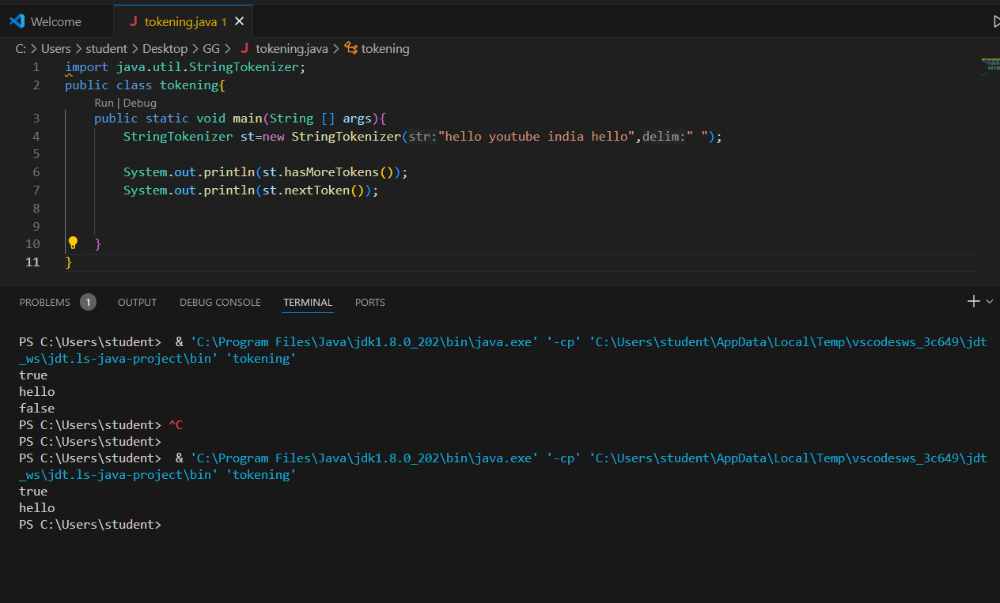

import java.util.StringTokenizer;

public class tokening{

public static void main(String [] args){

StringTokenizer st=new StringTokenizer("hello youtube india hello"," ");

System.out.println(st.hasMoreTokens());

System.out.println(st.nextToken());

2.st.nextToken()

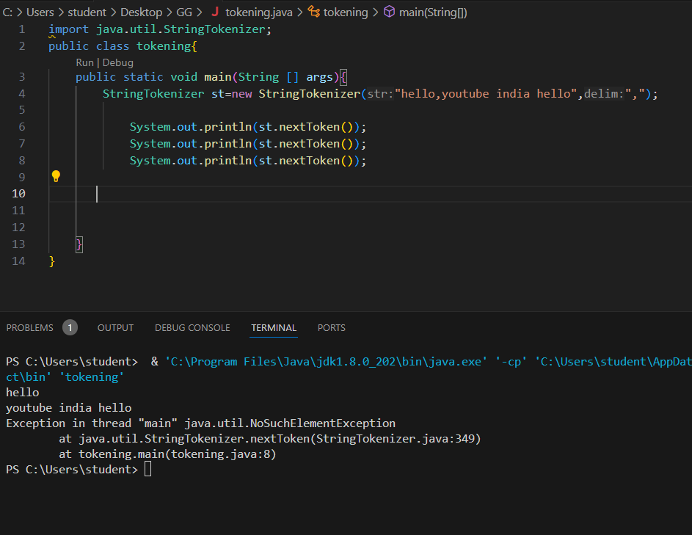

import java.util.StringTokenizer;

public class tokening{

public static void main(String [] args){

StringTokenizer st=new StringTokenizer("hello,youtube india hello",",");

System.out.println(st.nextToken());

System.out.println(st.nextToken());

System.out.println(st.nextToken());

}

}

}

}

3. st.hasMoreElements()

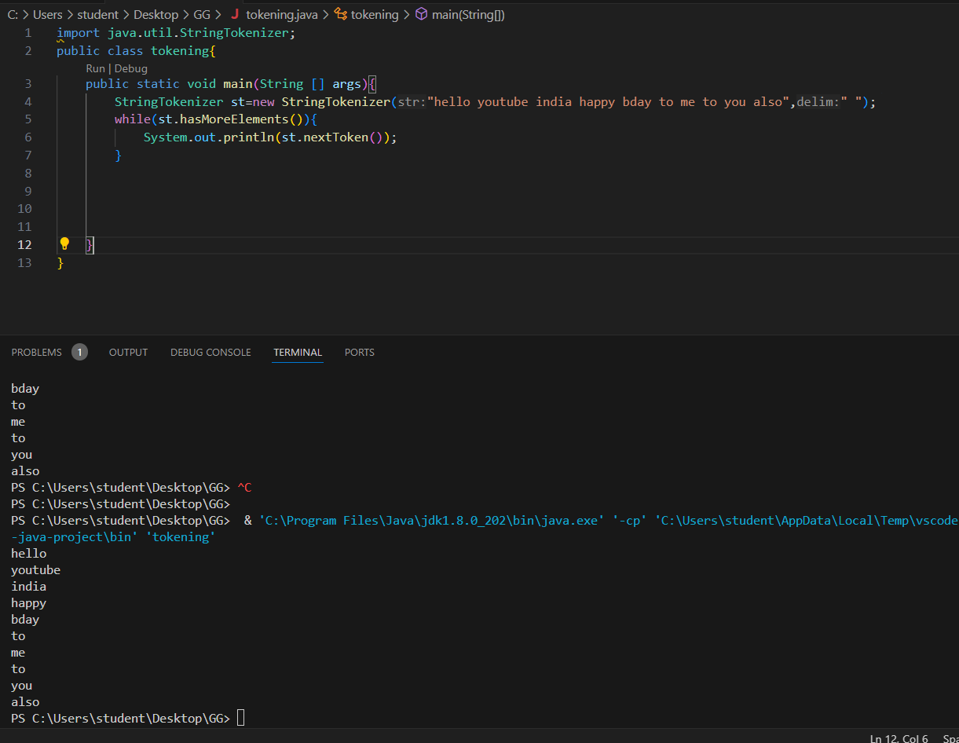

import java.util.StringTokenizer;

public class tokening{

    public static void main(String [] args){

        StringTokenizer st=new StringTokenizer("hello youtube india happy bday to me to you also"," ");

        while(st.hasMoreElements()){

            System.out.println(st.nextToken());

        }

    }

}

4. st.nextElement()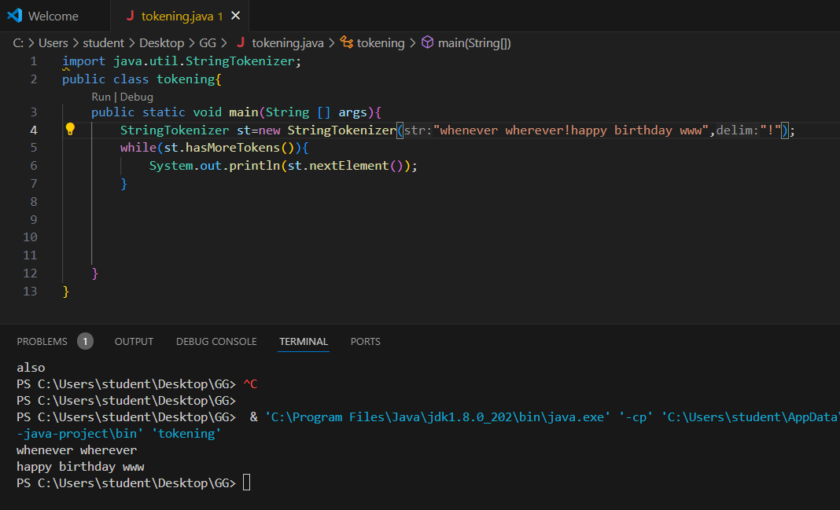

5.

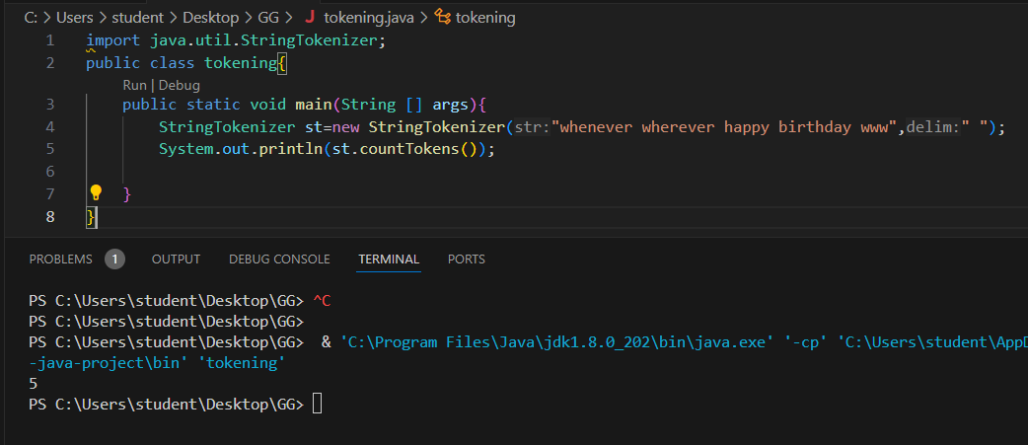

6. 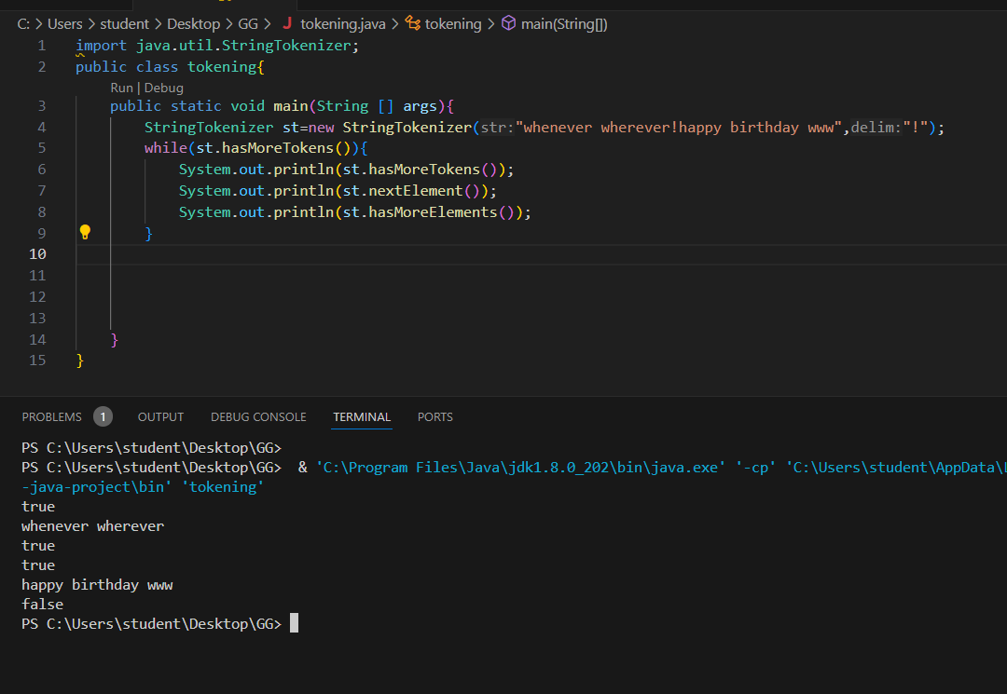

import java.util.StringTokenizer;

public class tokening{

    public static void main(String [] args){

        StringTokenizer st=new StringTokenizer("whenever wherever!happy birthday www","!");

        while(st.hasMoreTokens()){

            System.out.println(st.hasMoreTokens());

            System.out.println(st.nextElement());

            System.out.println(st.hasMoreElements());

        }

    }

}

ARRAYS IN JAVA

1.declare

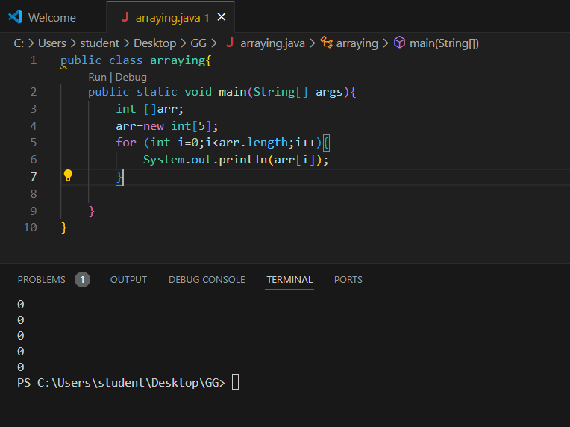

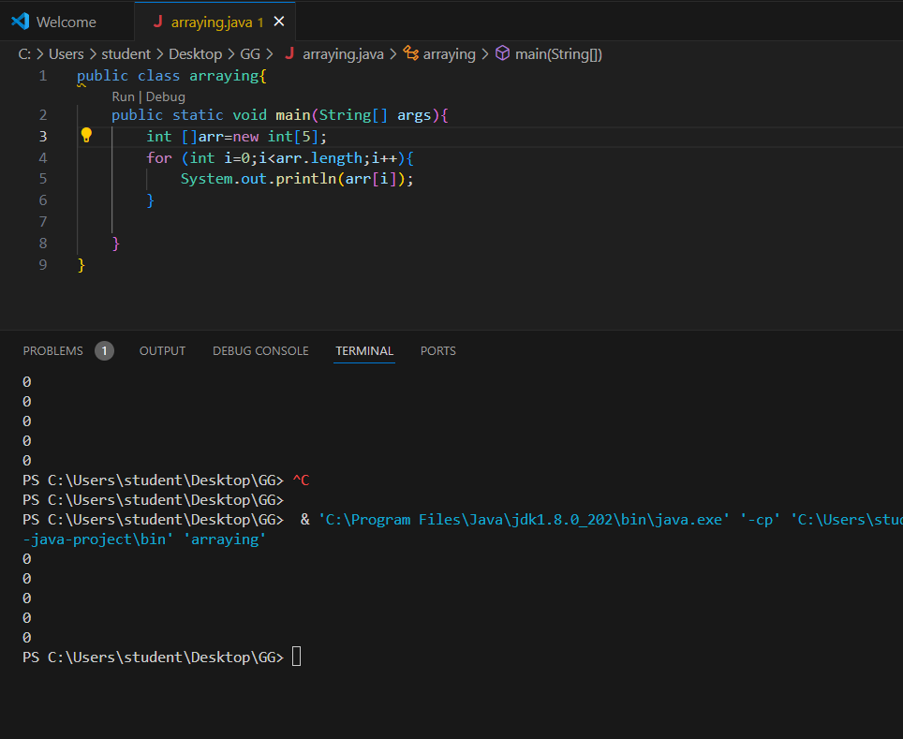

public class arraying{

    public static void main(String[] args){

        int []arr=new int[5];

        for (int i=0;i<arr.length;i++){

            System.out.println(arr[i]);

        }

    }

}

2.

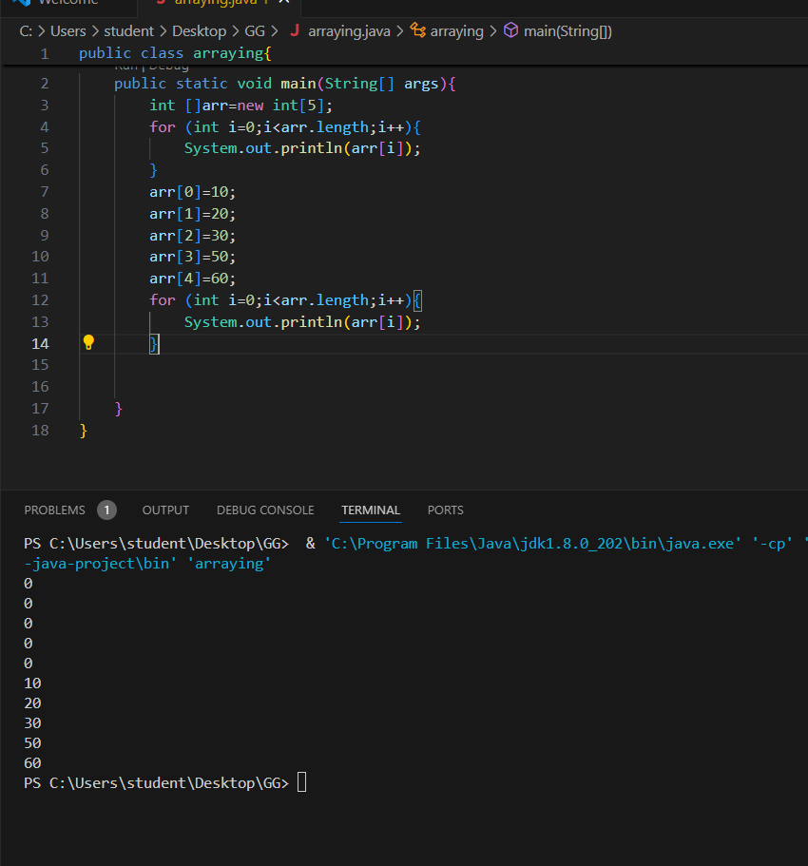

public class arraying{

    public static void main(String[] args){

        int []arr=new int[5];

        for (int i=0;i<arr.length;i++){

            System.out.println(arr[i]);

        }

        arr[0]=10;

        arr[1]=20;

        arr[2]=30;

        arr[3]=50;

        arr[4]=60;

        for (int i=0;i<arr.length;i++){

            System.out.println(arr[i]);

        }

    }

}

import java.util.Scanner;

class student{

public int roll;

public String name;

student(int roll,String name){

this.roll=roll;

this.name=name;

}

}

public class Main{

public static void main(String[] args){

System.out.println("enetr no.of student deatils=");

Scanner sc=new Scanner(System.in);

int n=sc.nextInt();

student [] arr=new student[n];

for (int i=0;i<arr.length;i++){

System.out.println("element at i="+i+": roll="+arr[i].roll+"name"+arr[i].name);

}

arr[0]=new student(1,"kamala");

arr[1]=new student(2,"galatta");

arr[2]=new student(3,"appna");

arr[3]=new student(4,"chillak");

arr[4]=new student(5,"tillak");

for (int i=0;i<arr.length;i++){

System.out.println("element at i="+i+": roll="+arr[i].roll+"name"+arr[i].name);

}

}

}